MHFC Team Camps are specially designed to allow High School coaches the flexibility and unique opportunity to install offense, defense and special teams on a college campus that caters to their own systems and operations. Individual Team time and Team Competition opportunities are built in throughout the camp schedule. Contact the MHFC Camp Coordinator, Jayden Riley, for more information.
Registration Info:
Fill out the form on our website and secure your spot based on the dates available. your non-refundable $500 TEAM deposit to: ﻿
www.markhallfootballcamps.com
Once your registration deposit is received, your team’s spot will be confirmed and you will receive all needed registration forms and additional Camp details such as lodging info, parking, maps, meals, schedules and other pertinent information for your staff and your players to ensure the best Team Camp experience.

Our sessions will include the following dates:
Session #1 June 23-25
Session #2 July 9-11
Session #3 July 27-29
We want every team to get the most they can get out of their time here on our campus. We are flexible with everything regarding the schedule with the exceptions of Meal Times and Quiet Hours.
More information about campus availability and resources will be available to you so that you can begin to plan your team camp and install schedule. We set up the MHFC Team Camp so that YOU can have time for YOUR team to prepare for the upcoming season.

Cost of MHFC Camp
A non-refundable $500 is due to the MHFC Camp as soon as possible for the TEAM to secure a spot. Deposit will cover damages as well as missing Keys.
Additionally, Camp attendance cost is $190.00 per person (Players / Coach).
Head Coach cost is covered.
All Athlete payments are made to the Head High School Coach / Football Program who will pay for the ENTIRE TEAM at, or prior to, check-in.
**Please DO NOT bring individual payments, checks or a large amounts of cash to camp. Please consolidate everything into one payment to make check in much faster**
MHFC Team Camp receives NO INDIVIDUAL ONLINE PAYMENTS and NO credit card payments from players or coaches.
Space is limited to the first 6 Teams per session that sign up, so estimates are needed as soon as possible to ensure and secure housing for all teams. Forms and dates will be set throughout the Spring.
Once the Team is registered, and upon being notified, every individual Coach and Athlete attending, needs to complete the waiver and submit payment to the Head Coach ASAP.

- Your payment will cover 3 days / 2 nights that also include:
- 6 Meals (2 Breakfasts, 2 Lunches, 2 Dinners)
- Lodging Accommodations.
- Practice Field Availability
- 7on7 Practice
- Meeting Room Availability
- Competition Opportunities

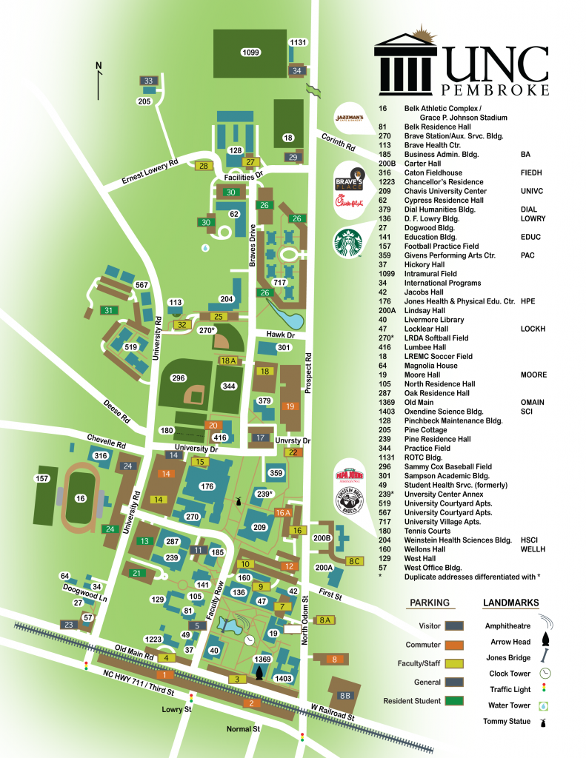
Team Camp Schedule:.

Monday:
1:30 PM – Check In
2:30 PM – Practice #1 On Your Own
4:00 PM – Dinner
7:00 PM – Practice #2 - 7on7 in Football Stadium
9:00 PM – Team Time
11:00 PM – Report to the Dorms / Quiet Time

Tuesday:
6:30 AM – Breakfast
8:30 AM – Practice #3 – On Your Own
11:00AM – Lunch
1:00 PM – Potential Practice Time / Team Time
3:30 PM – Practice #4 – On Your Own
4:00 PM – Dinner
7:00 PM – Practice #5 – 7on7 in Football Stadium
9:30 PM – Team Time
11:00 PM – Report to Dorms / Quiet Time

Wednesday:
6:30 AM – Breakfast
8:30 AM – Practice #6 – On Your Own
11:00 AM – Lunch
2:00 PM – Team Check Out

Housing / Dorms
All camp participants will be staying in On-Campus Housing such as Cypress, Oak or Pine Halls. These dorms are designed using suites. Each suite can accommodate 4 camp participants (2 bedrooms - 2 per room) Each suite is also equipped with its own common area with 2 couches and bathroom (toilet, sink, shower).
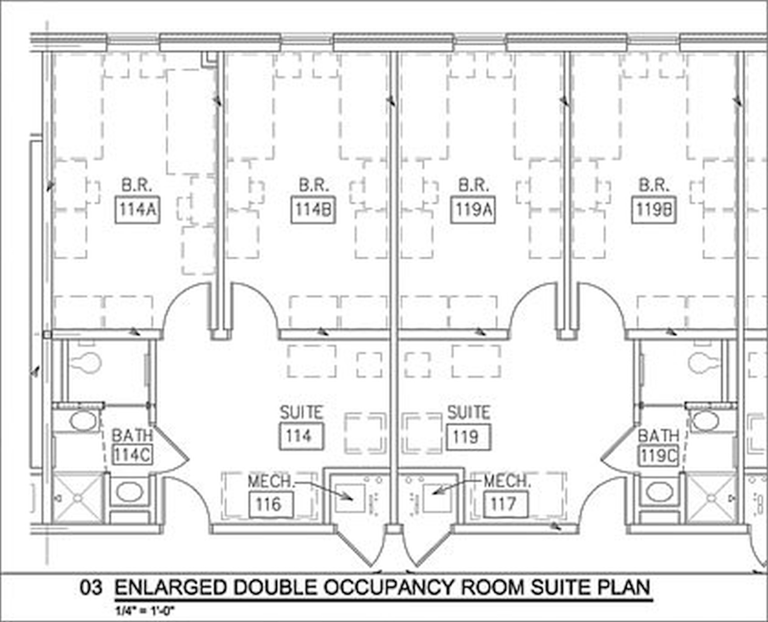
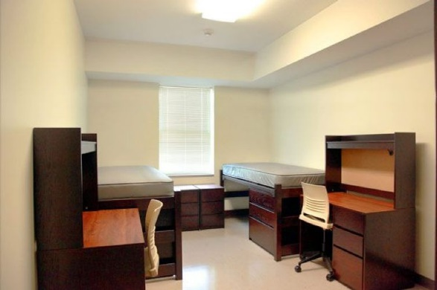

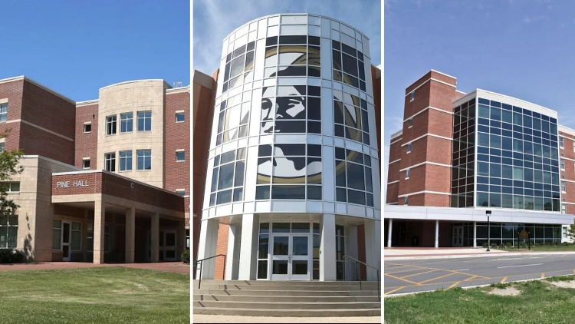

Meals
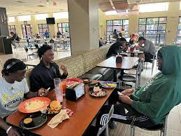

A total of 6 All-You-Can-Eat meals will be offered in the Chavis Student Center Dining Hall:
2 Breakfast
2 Lunch
2 Dinner

Team Camp Schedule
Day 1:
1:30: Check – In
2:10: Head Coaches Meeting
2:30: Practice Time
4:00: Dinner
7:00: Practice Time – 7on7 in the Football Stadium
9:00: Team Time
11:00: Report to the Dorms / Quiet Time
Day 2:
6:30: Breakfast
7:30 – 9:00: Practice Time / Team Time
9:30 – 11:00: Practice Time / Team Time
11:00: Lunch
1:00: Practice Time/ Team Time
3:30: Practice Time / Team Time
4:00: Dinner
7:00: Practice Time – 7on7 in the Stadium
9:30: Team Time
11:00: Report to Dorms / Quiet Time

Day 3:
6:30: Breakfast
7:30-9:00: Practice Time / Team Time
9:30 – 11:00: Practice Time / Team Time
11:00: Lunch
12:00: Practice Time
2:00: Team Check Out

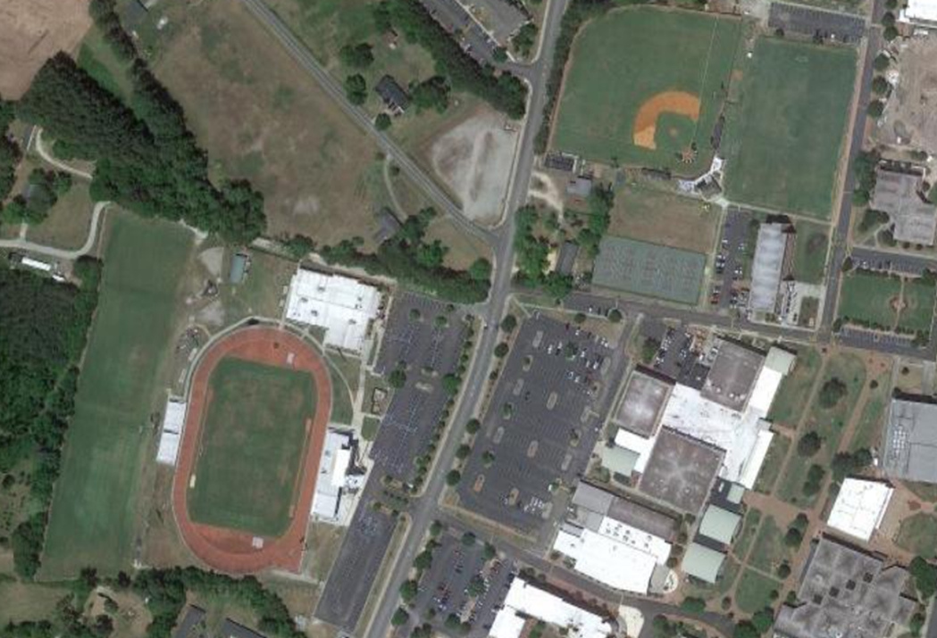
PRACTICE / GAME FIELDS
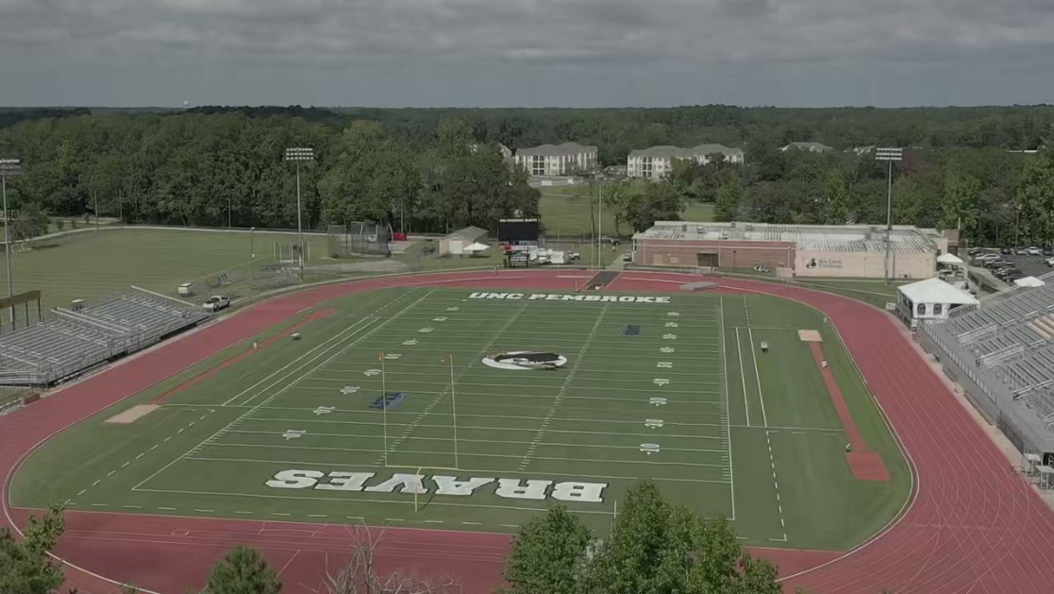
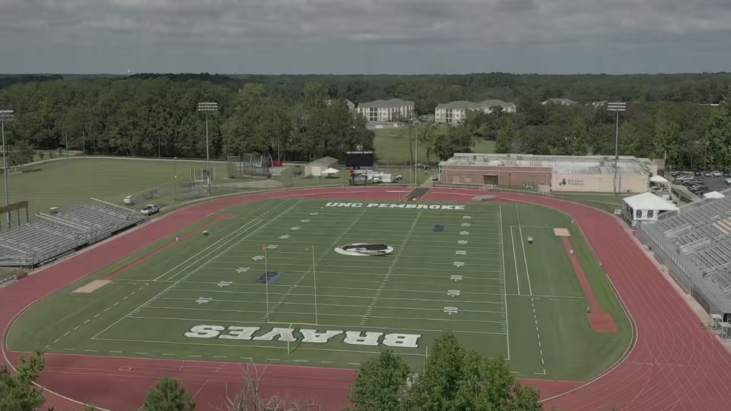
LMBEE
FIELD

